OpenERP - Printing Common Problem

Question: When I print, It just keep on “Loading...”; What should I do?

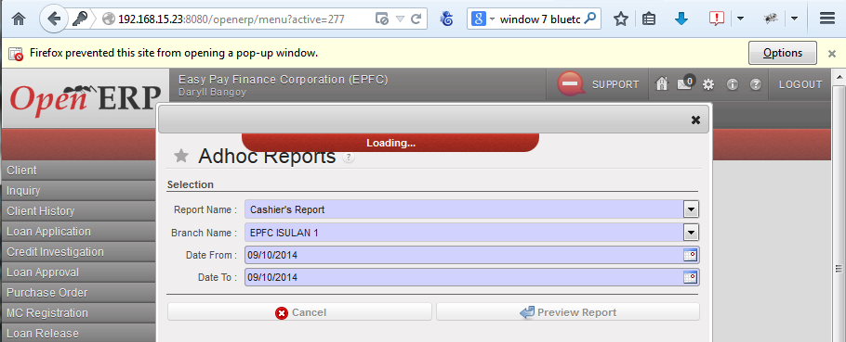

Answer: If you notice the yellow bar below the address bar that says ”Firefox prevented this site from opening a pop-window.”, It only means that the pop-up window is blocked, and it is the default settings for Firefox browser or the Firefox preference may be resetted if previously configured.
To fix the issue, there are two (2) options to allow printing, follow one (1) of the options below:

Option 1: Allow pop-window for the site:

- Click “Options” button.
- Select “Allow pop-up for ” followed by site IP or address.
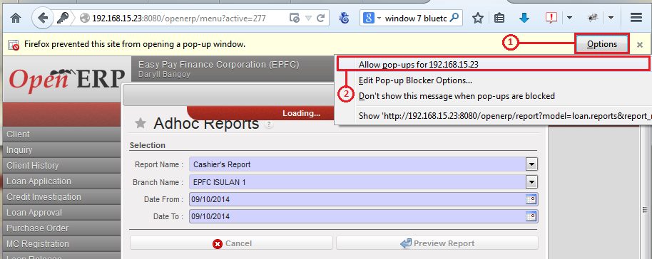
- Print the report again.

Option 2: (Recommended) Add the site IP or address to allowed site list.

- Open “Tools” menu, to access.
- Select “Options”.
Access “Tools” via Main-menu press “Alt+T”:
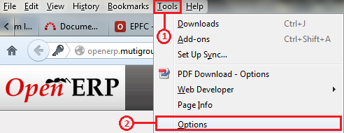
Access “Tools” via widget menu:
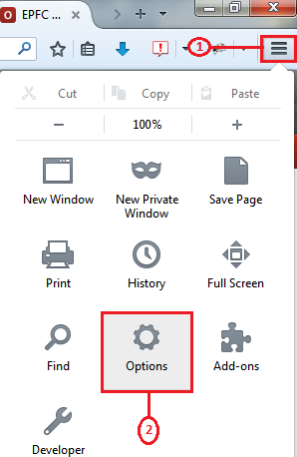

- Select “Content” tab from “Options” window.
- Click “Exceptions...” button.
- Allowed Site Pop-ups: Type the site IP or address to “Address of website” textbox.
- Click “Allow” button.
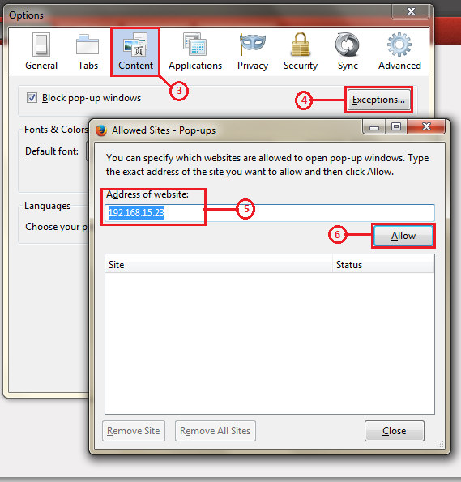
- Close all Firefox sub windows.
- Print the report again.

